Saturday 18th January

The Launch Party (from 10am)

Kemsing Library was officially opened on 1st January 1970 by the then, Kent and England Cricket Captain, Colin Cowdrey.

**Join with us in celebrating**

**Kemsing Library’s 50th birthday!**

Come along and meet our Special Guests

Take a peek (and maybe a nibble!) at the official

Birthday Cake

Enjoy a Kemsing Library ‘Through the Years’ display

Take part in the Kemsing Bake-off competition.

The Kemsing Bake-off Competition

*- in association with the Kemsing WI and the Craft Group*

3 categories: 8 – 11yrs - chocolate chip cupcake/ cookie

12 – 17yrs - chocolate sponge

18yrs+ - sponge and/or fruit cake

(with specified ingredients)

Pick-up your Bake-off entry form, from Kemsing Library

Entry forms to be in by 14 December 2019

Thursday 23rd January

The Author Talk (at 2pm)

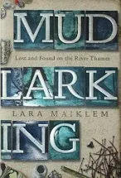

*“… finding lost things is the best way*

*of losing yourself…”*

- The Guardian

**Lara Maiklem**

Mudlarking: Lost and Found on the River Thames

BBC Radio 4 Book of the Week

Sunday Times Bestseller

*- in association with The Kemsing Heritage Centre*

*and Sevenoaks Museum*

Tickets are £3 and booking is essential.

Please email [kemsinglibrary@kent.gov.uk](mailto:kemsinglibrary@kent.gov.uk) telephone 03000 41 31 31 or speak to a member of staff

Refreshments available at minimal charge

Copies of ‘Mudlarking’ will be available to b

Saturday 25th January

The Children’s Bit! (10 – 11.30am)

Children’s

Craft Activities

for under 8’s





**Bookworm bookmarks**



**Balloon Art**

Birthday Pong!



£1 per child Booking essential

[](https://www.google.co.uk/url?sa=i&rct=j&q=&esrc=s&source=images&cd=&cad=rja&uact=8&ved=0ahUKEwin1N-GgeHXAhVIuRoKHWmXCd8QjRwIBw&url=https://en.wikipedia.org/wiki/Twitter&psig=AOvVaw3RFfpivEBZbHLJI9cJGcui&ust=1511949527460049)

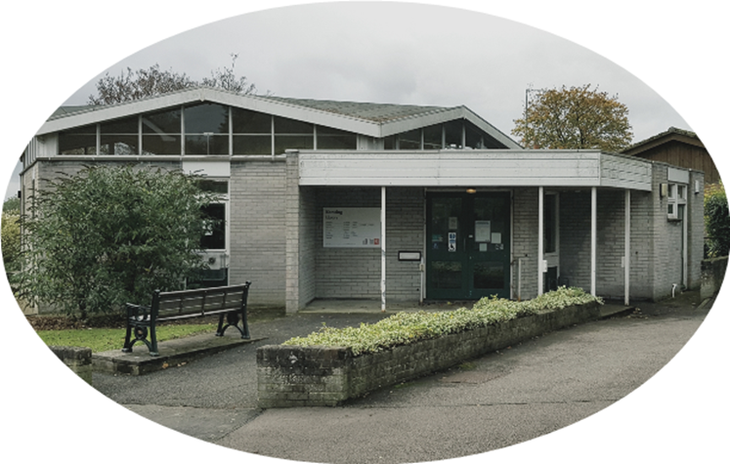

50, not out!

Kemsing Library

Happy Birthday